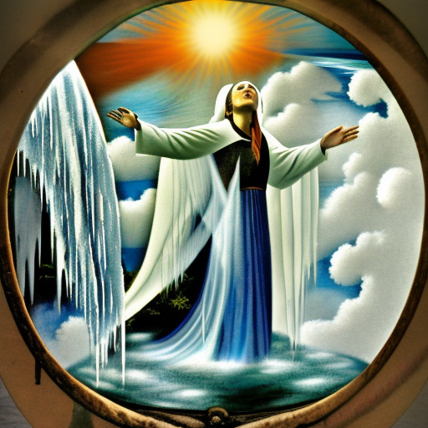
THE GREAT ROUND MIRROR

The Spirit of God rests above Heavenly waters
The Great Round Mirror reveals
Realms of exceeding great delight
The Woman of the Waterfall baptizes
Rage & anger disappear with the touch of earth
Elephants march through frozen lands
Craving & suffering cease
Man makes loves with Holy Emotion
Right minds with right views come to pass

